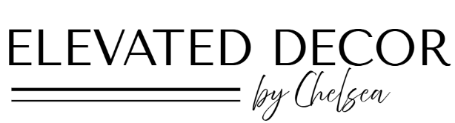

CHARCUTERIE PRICING
Size | Serves | Price Range | Includes
Mini board | 2-4 people | $45 - $100 | Perfect for date night. Includes 2 cheeses, 1 meat, fruit and nuts
Medium board | 5-10 people | $100 -$200 | Great for small gatherings. 3 cheeses, 2 meats, fruit, nuts, crackers, jam
Large board | 10-20 people | $200- $400 | For parties or events, 4-5 cheeses, 3 meats, dips, fruits, nuts and more
Luxe Grazing Table | 25+ people | $600 + | Statement setup with décor. Full spread with abundant variety and styling

TABLE SCAPE PRICING
- Basic table styling: linens, 1-2 centerpiece, formal place settings with chargers,
- Elevated table styling: layered décor, more than one centerpiece + detailed accents

Guest Count | Estimated Price Range
2-4 people | $150 - $250
4-6 people | $250-$350
8-10 people | $400 -$600
10-20 people (2-3 tables) | $600 - $800
20-40 people (3-4 tables | $800 - $1,600
40+ | Custom quote

HOLIDAY DECOR PRICING
Custom quotes provided based on what decor items will be used (client’s own items, rental items or items bought through the business).

